**E-Book & Manga Reader**

**SEMINAR-1 REPORT**

***Submitted by***

**M ABHISHEK – RA2011027020041**

**S. SABARISH KUMAR – RA2011027020056**

**VISHAL – RA2011027020070**

Under the guidance of

**Ms.P.VIDYASRI, AP/CSE**

**Ms.M.S.MINU, AP/CSE**

***In partial fulfillment for the award of the degree***

***of***

**BACHELOR OF TECHNOLOGY**

***in***

**COMPUTER SCIENCE AND ENGINEERING**

***of***

**FACULTY OF ENGINEERING AND TECHNOLOGY**



**SRM INSTITUTE OF SCIENCE AND TECHNOLOGY**

**RAMAPURAM CAMPUS, CHENNAI-600089**

**NOV 2022**

# SRM INSTITUTE OF SCIENCE AND TECHNOLOGY

(Deemed to be University Under Section 3 of UGC Act, 1956)

# BONAFIDE CERTIFICATE

Certified that the Seminar-I report titled “**E-BOOK & MANGA READER**” is the bonafide work of “**M ABHISHEK [RA2011027020041], S. SABARISH KUMAR [RA2011027020056], VISHAL [RA2011027020070]”** submitted for the course 18CSP103L Seminar – I. This report is a record of successful completion of the specified course evaluated based on literature reviews and the supervisor. No part of the Seminar Report has been submitted for any degree, diploma, title, or recognition before.

**SIGNATURE SIGNATURE**

Ms.P.VIDYASRI Dr. K. RAJA, M.E., Ph.D.,

Assistant Professor Professor and Head

Computer Science & Engineering Computer Science & Engineering

SRM Institute of Science and Technology SRM Institute of Science and Technology

Ramapuram, Chennai. Ramapuram, Chennai.

Submitted for the Seminar-1 Viva Voce Examination held on ………………… at SRM Institute of Science and Technology, Ramapuram Campus, Chennai-600089.

**EXAMINER 1 EXAMINER 2**

**SRM INSTITUTE OF SCIENCE AND TECHNOLOGY RAMAPURAM, CHENNAI - 89**

**DECLARATION**

We hereby declare that the entire work contained in this project report titled “**E-BOOK & MANGA READER**” has been carried out by **M ABHISHEK** [REG NO: RA2011027020041], **S. SABARISH KUMAR** [REG NO: RA2011027020056], **VISHAL** [REG NO: RA2011027020070] at SRM Institute of Science and Technology, Ramapuram Campus, Chennai- 600089, under the guidance of **Ms.P.VIDYASRI, Assistant Professor**, Department of Computer Science and Engineering.

**Place: Chennai**

**Date:**

**M ABHISHEK**

**S. SABARISH KUMAR**

**VISHAL**

**ABSTRACT**

The purpose of manga and eBooks Reader is to make a place where all eBooks and manga can be read in a single platform and help improve people’s knowledge and leverage this Knowledge to improve. These are portable libraries provided with a cost-effective learning infrastructure that enables anytime, anywhere, self-placed and Interactive learning. With the development of information and communication through technology, it has become possible for students to read and store hundreds and thousands of e books which hold extensive persona; libraries in their smart phones, tablets and computers. A monthly subscription website for people who are interested to learn and read without interruption at an affordable price.

# TABLE OF CONTENTS

## Page. No

**ABSTRACT ………………………………………………………………… v**

LIST OF FIGURES ………………………………………………………… vi

1. INTRODUCTION………………………………………………………. 1

1.1 Introduction ………………………………………………………. 1

1.1.1 Problem Statement …………………………………... 1

1.2 Aim of the project ………………………………………………… 1

1.3 Project Domain ……………………………………………….. 2

1.4 Scope of the Project ……………………………………………… 2

1.5 Methodology …………………………………………………. 2

1. LITERATURE REVIEW ……………………………………………… 3
2. PROJECT DESCRIPTION ………………………………….………… 6

3.1 Existing System ………………………………………………..… 6

3.2 Proposed System …………………………………………………. 6

3.2.1 Advantages …………………………………………….. 6

3.3 Feasibility Study …………………………………………….. 6

* + 1. Economic Feasibility …………………………………... 7
    2. Technical Feasibility ………………………………….. 7
    3. Social Feasibility ………………………………………. 7

|  |  |  |
| --- | --- | --- |
| 3.4 | System Specification ……………………………………………… | 7 |

* + 1. Hardware Specification ………………………………… 7
    2. Software Specification …………………………………. 8

## MODULE DESCRIPTION ………………………………………….. 9

|  |  |  |  |  |
| --- | --- | --- | --- | --- |
| 4.1 | General Architecture …………………………………………….. | | | 9 |
| 4.2 | Design Phase …………………………………………………….. | | | 10 |
|  | 4.2.1 | | Data Flow Diagram ……………………………………... | 10 |
|  | 4.2.2 | | Collaboration Diagram ………………………………….. | 11 |
|  | 4.2.3 | | Use Case Diagram ……………………………………… | 12 |
|  | 4.2.4 | | Sequence Diagram ……………………………………… | 13 |
| 4.3 | | Module Description …………………………………………….. | | 14 |

|  |  |  |
| --- | --- | --- |
| 4.3.1 | MODULE1: DATA COLLECTION AND TRAINING DATA …………………………………………………… | 14 |
| 4.3.2 | Login - Page …………………………………………….. | 14 |
| 4.3.3 | Main – Page ……………………………………………... | 14 |
| 4.3.4 | Recently Read …………………………………………… | 14 |
| 4.3.5 | Offers ……………………………………………………. | 14 |
| 4.3.6 | Suggestions ……………………………………………… | 14 |
| 4.3.7 | DATASETS SAMPLE ………………………………….. | 15 |

|  |  |  |
| --- | --- | --- |
| 4.3.7.1 | Building the Model ……………………………. | 15 |
| 4.3.7.2 | Testing the Model ……………………………… | 15 |
| 4.3.7.3 | Implementing the model ………………………. | 15 |

## IMPLEMENTATION AND TESTING ………………………………. 16

|  |  |  |  |  |
| --- | --- | --- | --- | --- |
| 5.1 | | Input and Output ………………………………………………….. | | 16 |
|  | | 5.1.1 | | Sign – In Page ...………………………………………… | 16 |
|  | | 5.1.2 | | Home Page ……………………………………………… | 17 |
| 5.2 | | Testing | | …………………………………………………………… | 17 |
|  | | 5.2.1 | | Types of Testing ………………………………………… | 17 |
|  | | 5.2.2 | | Unit testing ………………………………………….. | 17 |
|  | | 5.2.3 | | Integration testing ………………………….……………. | 18 |
|  | | 5.2.4 | | Test Result …………………………………….………… | 18 |
| 5.3 | | Testing | | Strategy ………………………………………………….. | 18 |
|  | |  | |  |  |
| **6** | | **RESULTS AND DISCUSSIONS ……………………………………...** | | | | **19** |
| 6.1 | | Efficiency of the Proposed System ……………………………….. | | 19 |
| 6.2 | | Comparison of Existing and Proposed System …………………… | | 19 |
| 6.3 | | Sample Code ……………………………………………………… | | 20 |

## CONCLUSION AND FUTURE ENHANCEMENTS ………………... 25

|  |  |  |
| --- | --- | --- |
| 7.1 | Conclusion ………………………………………………………….. | 25 |
| 7.2 | Future Enhancements ……………………………………………..... | 25 |

## SOURCE CODE & POSTER PRESENTATION …………………… 26

|  |  |  |
| --- | --- | --- |
| 8.1 | Sample Code ………………………………………………………. | 26 |

## References …………………………………………………………………… 30

**LIST OF FIGURES**

|  |  |  |  |  |
| --- | --- | --- | --- | --- |
| Fig no. | Figure name | Page no. | | |
| 4.1 | Architecture Diagram………………………………….. | | 9 |
| 4.2 | Data Flow Diagram……………………………………. | | 10 |
| 4.3 | Collaboration Diagram………………………………… | | 11 |
| 4.4 | Use Case Diagram……………………………………... | | 12 |
| 4.5 | Sequence Diagram……………………………………... | | 13 |
| 4.6 | Test Image……………………………………………... | | 15 |
| 5.1 | Sign-in page …………………………………………… | | 16 |
| 5.2 | Home page……………………………………………... | | 17 |
| 5.3 | Test Image……………………………………………... | | 18 |
| 6.1 | Featured Manga………………………………………... | | 24 |
| 6.2 | Arrivals………………………………………………… | | 24 |

# Chapter 1 INTRODUCTION

## Introduction

This document lays out a project plan for the development of “E-book/Manga Reader” The goal of this project is to provide easy access to online E-book and manga to build a community in our society. This is a book store and reader, customers can buy and read it the website. Through the Featured and Offers Section, it can be made that the user experience’s the best entertainment and knowledge to grow and implement their knowledge Improve.

These portable libraries provide a cost-effective learning infrastructure that enables anytime, anywhere, self-paced and interactive learning. With the development of information and communication technology, it has become possible for students’ tablets, smartphones and computers to store thousands of e-books which hold extensive personal libraries in their hands and pockets.

## Problem Statement

Firstly, we need to understand the problem in an efficient way. The current problem is that there are individual platforms to read eBooks and manga but not a single platform which connects and contains all eBooks and manga. This makes the user less interested in gaining knowledge and read books and manga to better themselves. This module does not provide the single pass solution to import a book and does not provide the provision to filter the contents selectively.

## Aim of the project

This project aims to create a website that makes it easy and accessible for the users to buy the latest and their favorite eBooks and manga to read and to spread the knowledge of books to everyone.

## Project Domain

The domain of the project is Java, CSS and Html. The progress of Java, CSS and Html techniques have been challenging when it comes Website building and Text Processing. Java uses various algorithms based on the requirement of the project.

## Scope of the Project

As we know that Japanese manga and eBooks from other countries are really rare and it's difficult to find them and read it in a proper way. To make it easier and comfortable we decided to create this website/web store in order to buy and read eBooks and manga.

## Methodology

## Introduction of two compression algorithms, DEFLATE and SEQUITUR, how to implement this SEQUITUR algorithm using JavaScript, why we have chosen JSZip, and how to use it decompress a compressed .epub file. As we demonstrated in the previous chapter, an EPUB file is actually compressed ZIP file. Since our project is to create a JavaScript EPUB reader web application, we need to understand how the file is compressed and how to decompress it, which algorithm to apply and how it works, whether we can implement one algorithm using JavaScript, which algorithm we will choose, and how to implement it using JavaScript. Lastly, I will show why we choose JSZip and which experiment we did to ensure it was good choice for our project. In our project, we need to decompress the compressed EPUB file and render it correctly in the web browser, after doing some research on lossless compression methods, we chose DEFLATE. It is a prefix code prepared by the Huffman algorithm. Each code is a series of bits, either 0 or 1, and represents an element in a specific “alphabet” (or Huffman tree). The core of Huffman coding is: the characters most used in the original file get the least amount of bits inside the compressed file.

# Chapter 2

# LITERATURE REVIEW

|  |  |  |  |
| --- | --- | --- | --- |
| **S.NO** | **TITLE** | **AUTHOR** | **TECHNICAL GAP** |
| **1** | A literature review and content analysis on interactive eBooks (2017) | Mehmet Kesim, Hakan Yıldırım | Poor image quality  Small image size make facial recognition more difficult. |
| **2** | E-safety and Digital Skills as Part of School Curriculum  (2016) | Lidija Kral | Several studies repo little or no power of generalization, when evaluating the training models in their own sets. Even the model that were trained using pre-processing techniques, which to eliminate the bias belonging to the data sets, showed limited results. Therefore, most of the results achieved so far. |
| **3** | Reading in the Digital Age (2016) | Badulescu, Dana | Massive data storage burden. The ML technology used in fa detection requires powerful data storage that may not be available to all users. Detection is vulnerable. A potential breach of privacy. |
| **4** | E-book atlases for tablet computers: the Atlas of the Columbia River Basin (2015) | Bernhard Jenny, Jane E. Darbyshire, Nicholas D. Arnold, Brooke E. Marston, Darrell A.McGie. | Ababoost is the algorithm used in this paper but it can be less susceptible to overcome of all the remaining algorithms. The main disadvantage of Adaboost is more sensitive to noisy data. The challenge occured in this task is more complexive as the model should target on the face mask but not on the human faces. It also acquires a high performance and more economic. |
| **5** | Building an E-Book Library (2014) | Marcy Zipke | The main risky factor here is if the human faces turned up side or not faced to the camera then the detection is critical as the model is not trained to detect the faces from a certain angle. |
| **6** | Self-authored e-books: Expanding young children's  literacy experiences and skills (2013) | Mary-Jane Shuker, Lisa Terreni | The factors that make the work complicate should be evaluated and a lot of training data sets needs to be taken as sample and perform testing. After considering the result of testing phase, one can conclude that the method can be efficient or not. |
| **7** | Empowering personalized learning with an interactive e-book learning system for elementary school students (2012) | Huang, Yueh-Min | Real world projects can be so challenging to the technology to come with the desired output and with no errors. |
| **8** | eBooks and Literacy in K–12 Schools (2012) | Felvegi, Emese, andKathryn I. Matthew. | The problem with these methods is that Mask- RCNN is computationally heavy and requires adequate computing power to run the model in real time. especially in places where such devices are not affordable. |
| **9** | The discourse on printed and electronic books: analogies, oppositions, and perspectives  (2014) | Velagić, Zoran | lack of control over their personal information  Many of the training datasets uses for facial recognition are dominating by light- skinned individuals. |

**Chapter 3**

**PROJECT DESCRIPTION**

## Existing System

The existing system runs based on the java and css coding language. The existing system consists of individual eBooks and manga which exist in different platforms and cannot be accessed with ease. The existing system doesn’t provide a very smooth user experience as the user cannot easily find the manga or eBooks he/she is looking for and even if they manage to find it, the price may be too high.

## Proposed System

The proposed system consists of a website which enables users to directly access all types of eBooks and manga in a single platform. The proposed system website enables users to take up a monthly subscription and enables users to enjoy their favorite Manga’s and eBooks without any disturbance.

* + 1. **Advantages**
* Large library of manga and e-books available
* Low cost
* Easy accessibility
* No advertisement

## Feasibility Study

A Feasibility study is carried out to check the viability of the project and to analyze the strengths and weaknesses of the proposed system. The application of usage of mask in crowd areas must be evaluated. The feasibility study is carried out in three forms

* Economic Feasibility
* Technical Feasibility
* Social Feasibility
  + 1. **Economic Feasibility**

The proposed system does not require any high cost equipment.

This project can be developed within the available software.

* + 1. **Technical Feasibility**

The proposed system is completely a web-based model. The main tools used in this project are CSS, java, and html. The above-mentioned tools are available for free and technical skills required to use this tool are practicable. From this we can conclude that the project is technically feasible.

* + 1. **Social Feasibility**

Social feasibility is a determination of whether project will be acceptable or not. Our project is User-friendly and there is no social issues. Our project must not threatened can be used by any user to enjoy the pleasure of reading manga and eBooks. The concept of making manga and eBook readily available through a digital platform enhances the interest of reading in our users and brings happiness to all.

## System Specification

* + 1. **Hardware Specification**
       - Processor - Intel i5-8250 CPU @1.60GHz 1.80GHz
       - 512 GB SSD
       - NVIDIA GEFORCE RTX
       - CPU QUAD CORES
    2. **Software Specification**
* Java
* Css
* Html

# Chapter 4

# MODULE DESCRIPTION

## General Architecture

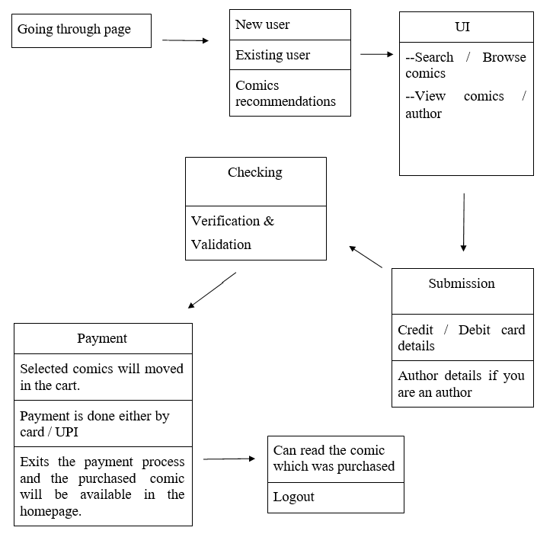

Figure 4.1: Architecture Diagram

Figure 4.1 represents the architecture diagram of the project. The above is a simple form of system design diagram which uses front end design. This shows a loop of functions that need to be executed when this project is implemented. This is a chain of operations through which this project is implemented.

## Design Phase

* + 1. **Data Flow Diagram**

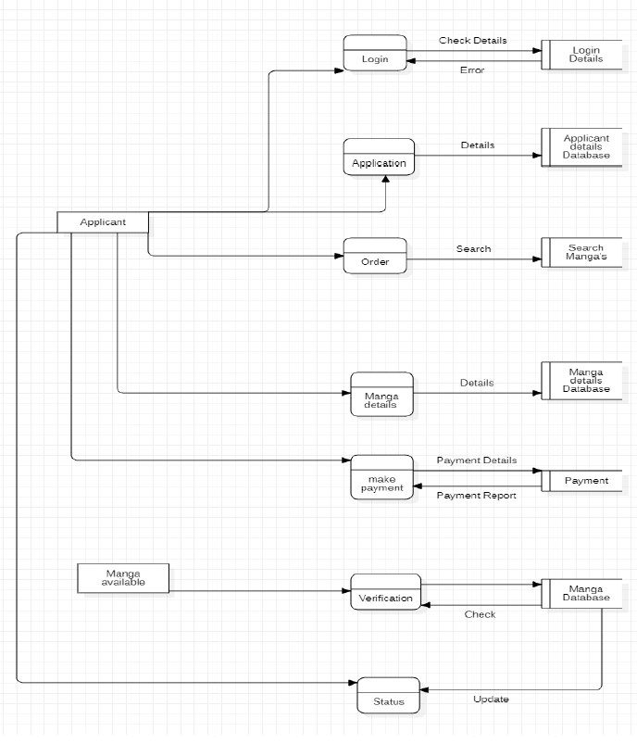

Figure 4.2: Data Flow Diagram

Figure 4.2 represents the flow diagram of our project. Data flow diagram is often used as a preliminary step to create an overview of the Books without going into stores, which can later be elaborated it normally consists of overall application dataflow and processes of the ZBooks. It contains all of the user flow and their entities such all the flow of User, Login, Application, Order,

Details, Publishers, Status. All of the below diagrams has been used for the visualization of data processing and structured design of the Result Management process and working flow.

* + 1. **Collaboration Diagram**

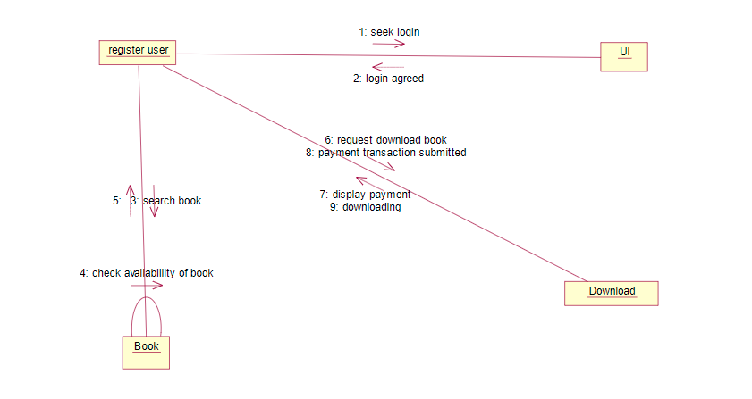

Figure 4.3: Collaboration Diagram

Figure 4.3 represent the Collaboration of our model. Communication diagram illustrate that object interact on a graph or network format in which object can be placed where in the diagram. In collaboration diagram the object can be placed in anywhere on the diagram. The collaboration comes from sequence diagram.

* + 1. **Use Case Diagram**

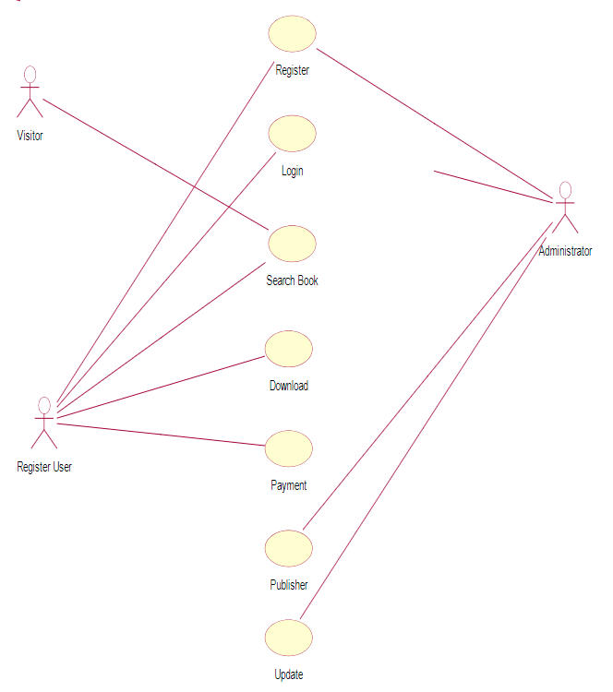

Figure 4.4: Use Case Diagram

Figure 4.4 represents the Use Case diagram of our model. UML provides use case diagram natation to illustrate the names of use case and author relationship between them. Use case diagram and case relationship are secondary in use case work use case text document.

* + 1. **Sequence Diagram**

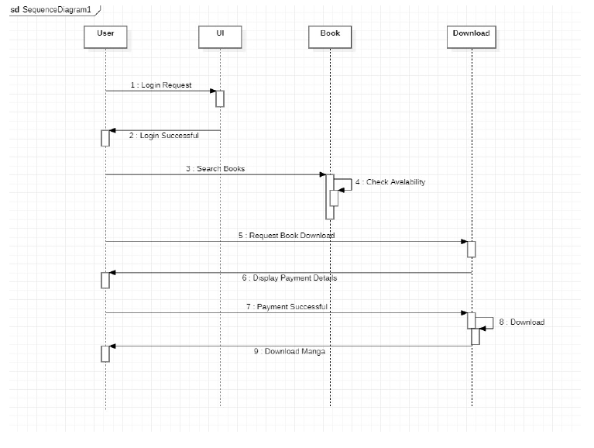

Figure 4.5: Sequence Diagram

Figure 4.5 represents sequence diagram, A sequence diagram represents the sequence and interactions of a given USE-CASE or scenario. Sequence diagrams can capture most of the information about the system. Most object to object interactions and operations are considered events and events include signals, inputs, decisions, interrupts, transitions and actions to or from users or external devices.

## Module Description

Our entire project is divided into two modules.

* + 1. **MODULE1: DATA COLLECTION AND TRAINING DATA**

Data Collection and training using Machine Learning Algorithms.

* + 1. **Login- Page**

The User needs it login with his/her user ID and password to set the various parameter of the system and access the sub-modules in module-1.

* + 1. **Main-Page**

The Main page contains 3 sub category's that are recently read, Offers, Suggestions.

* + 1. **Recently read**

It consists of the books and manga the user have recently read. This collects information for the website to make suggestions related to same genre.

* + 1. **Offers**

These are the offers that are provided for the user to buy books and manga in a combo.

* + 1. **Suggestions**

It consists of books that are similar to the genre the user has read before.

* + 1. **MODULE2: DATASETS SAMPLE**

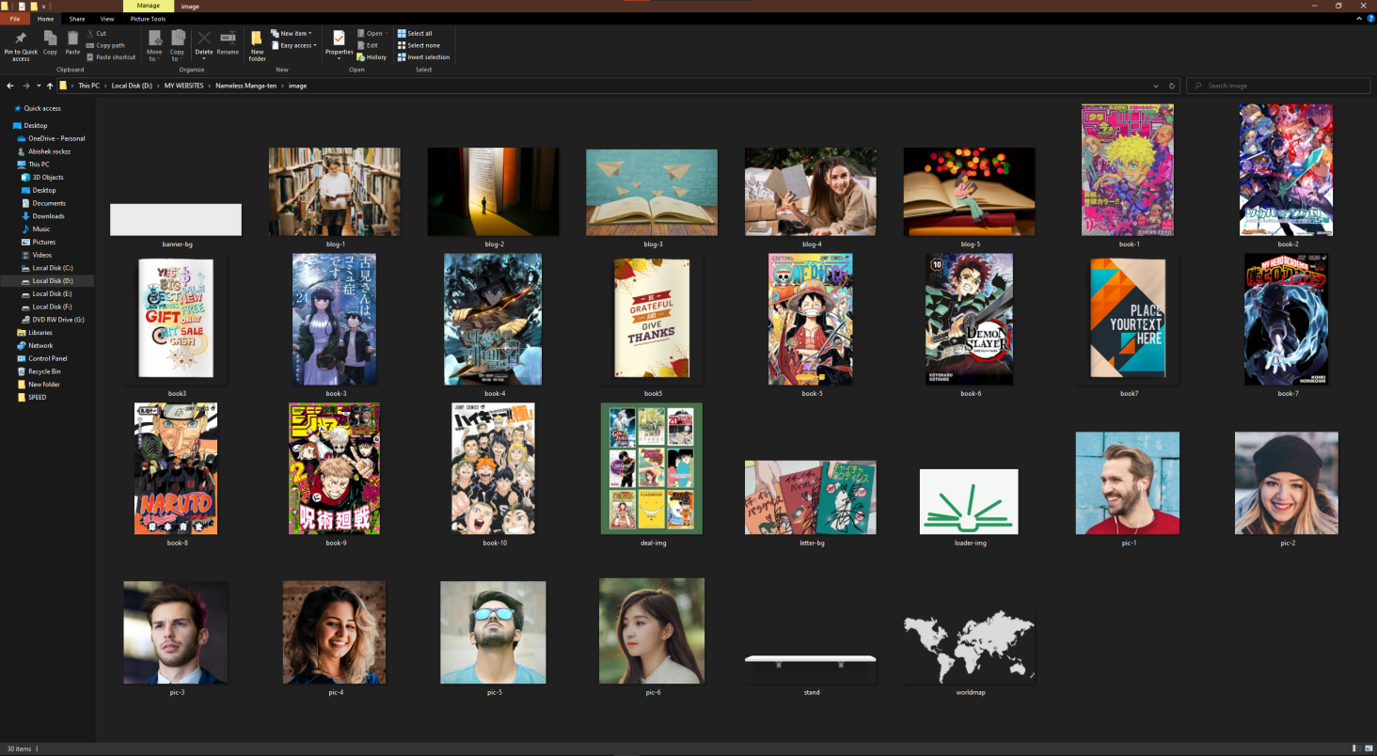

Figure 4.6: Cover pages of manga & E-book

* + 1. **Building the Model**
       - The next part is building the model. The base model with Tachiyomi, adding model parameters, collecting the model, coaching the model, and there-fore the last is saving the model for the long run prediction method.
    2. **Testing the Model**
* To make sure the model can predict well, there are steps in testing model. The first step is making predictions on the testing set.
  + 1. **Implementing the model.**
       - On test by user, user will be able to interact with the home page and the other stuffs.

# Chapter 5

# IMPLEMENTATION AND TESTING

## Input and Output

* + 1. **Login**

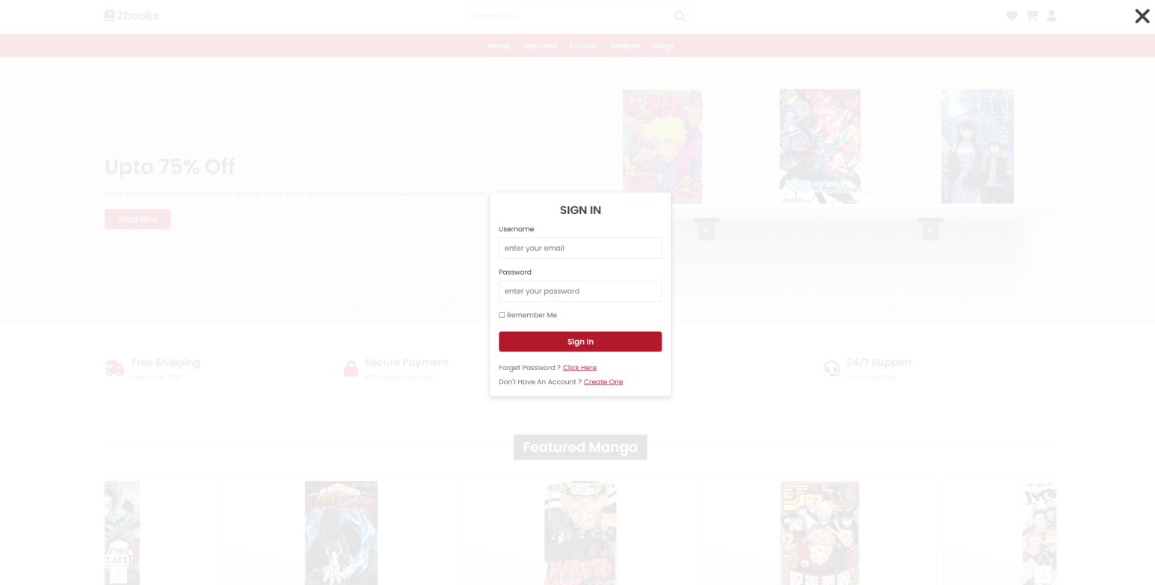

Figure 5.1: Sign page

* + 1. **After Signing In**

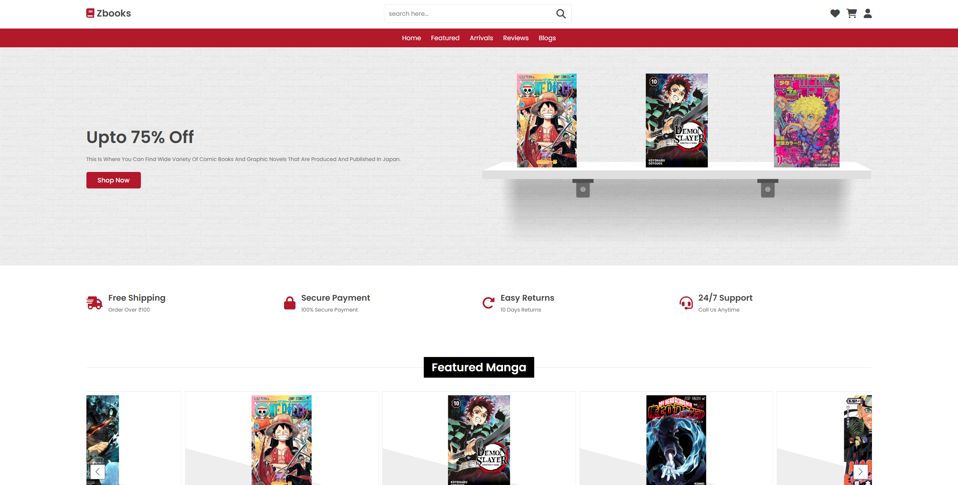

Figure 5.2: Home page

## Testing

Testing is the process of evaluating a system or its component(s) with the intent to find whether it satisfies the specified requirements or not.

* + 1. **Types of Testing**
    2. **Unit testing**

Unit testing is a beneficial software testing method where the units of source code is tested to check the efficiency and correctness of the program.

* + 1. **Integration testing**

Integration testing is the phase in software testing in which individual software modules are combined and tested as a group. Integration testing is conducted to evaluate the compliance of a system or component with specified functional requirements.

* + 1. **Test Result**



Figure 5.3: Test Image

## Testing Strategy

* Unit testing: Unit testing verifies the bits of code to check the viability of the code.
* Integration testing: Integration testing is carried out to the efficiency of the model with functional requirements.

# Chapter 6

# RESULTS AND DISCUSSIONS

## Efficiency of the Proposed System

The goal of these experiment is to create awareness and knowledge the citizens about the eBooks and Japanese Manga’s that are available for them to read in one platform. This website helps the user to be more efficient and effective when it comes to reading books and gaining knowledge, through the proposed system the users will be able to gain a wider range of knowledge and reach about eBooks and manga that was not available in a single website. And the website’s Suggestion system helps to go through the catalog of books and manga that are similar to the liking of the user’s past books.

## Comparison of Existing and Proposed System

The existing system has the each of the individual e books and manga exists in different platforms and some are not even in digital form. Most users cannot find their book of interest in an individual platform and even if they do find it, either the price is too high or they have too many ads that block most of the texts. According the current issues that exists, our proposed method is that a single website that contains all the books and manga from all the existing store. A month subscription website for everyone who interest to read books and manga's without any interruption. And it is at an affordable price so that anyone can access.

## Sample Code

1. <header class="header">
2. <div class="header-1">
3. <a href="#" class="logo"> <i class='fas fa-book' style='font: size 18px;color:red'></i> The Nameless Manga-Ten </a>
4. <form action="" class="search-form">
   1. <input type="search" name="" placeholder="search here..." id="search-box">
   2. <label for="search-box" class="fas fa-search"></label>
5. </form>
6. <div class="icons">
   1. <div id="search-btn" class="fas fa-search"></div>
   2. <a href="#" class="fas fa-heart"></a>
   3. <a href="#" class="fas fa-shopping-cart"></a>
   4. <div id="login-btn" class="fas fa-user"></div>
7. </div>
8. </div>
9. <div class="header-2">
10. <nav class="navbar">
    1. <a href="#home">home</a>
    2. <a href="#featured">featured</a>
    3. <a href="#arrivals">arrivals</a>
    4. <a href="#reviews">reviews</a>
    5. <a href="#blogs">blogs</a>
11. </nav>
12. </div>
13. </header>
14. <!-- header section ends -->
15. <!-- bottom navbar -->
16. <nav class="bottom-navbar">
17. <a href="#home" class="fas fa-home"></a>
18. <a href="#featured" class="fas fa-list"></a>
19. <a href="#arrivals" class="fas fa-tags"></a>
20. <a href="#reviews" class="fas fa-comments"></a>
21. <a href="#blogs" class="fas fa-blog"></a>
22. </nav>
23. <!-- login form -->
24. <div class="login-form-container">
25. <div id="close-login-btn" class="fas fa-times"></div>
26. <form action="">
27. <h3>sign in</h3>
28. <span>username</span>
29. <input type="email" name="" class="box" placeholder="enter your email" id="">
30. <span>password</span>
31. <input type="password" name="" class="box" placeholder="enter your password" id="">
32. <div class="checkbox">
    1. <input type="checkbox" name="" id="remember-me">
    2. <label for="remember-me"> remember me</label>
33. </div>
34. <input type="submit" value="sign in" class="btn">
35. <p>forget password ? <a href="#">click here</a></p>
36. <p>don't have an account ? <a href="#">create one</a></p>
37. </form>
38. </div>
39. <!-- home section starts -->
40. <section class="home" id="home">
41. <div class="row">
42. <div class="content">
    1. <h3>upto 75% off</h3>
    2. <p>This is where you can find wide variety of comic books and graphic novels that are produced and published in Japan.</p>
    3. <a href="#" class="btn">shop now</a>
43. </div>
44. <div class="swiper books-slider">
    1. <div class="swiper-wrapper">
       1. <a href="#" class="swiper-slide"><img src="image/book-1.png" alt=""></a>
       2. <a href="#" class="swiper-slide"><img src="image/book-2.png" alt=""></a>
       3. <a href="#" class="swiper-slide"><img src="image/book-3.png" alt=""></a>
       4. <a href="#" class="swiper-slide"><img src="image/book-4.png" alt=""></a>
       5. <a href="#" class="swiper-slide"><img src="image/book-5.png" alt=""></a>
       6. <a href="#" class="swiper-slide"><img src="image/book-6.png" alt=""></a>
    2. </div>
    3. <img src="image/stand.png" class="stand" alt="">
45. </div>
46. </div>
47. </section>
48. <!-- home section ense -->
49. <!-- icons section starts -->
50. <section class="icons-container">
51. <div class="icons">
52. <i class="fas fa-shipping-fast"></i>
53. <div class="content">
    1. <h3>free shipping</h3>
    2. <p>order over ₹100</p>
54. </div>
55. </div>
56. <div class="icons">
57. <i class="fas fa-lock"></i>
58. <div class="content">
    1. <h3>secure payment</h3>
    2. <p>100 secure payment</p>
59. </div>
60. </div>
61. <div class="icons">
62. <i class="fas fa-redo-alt"></i>
63. <div class="content">
    1. <h3>easy returns</h3>
    2. <p>10 days returns</p>
64. </div>
65. </div>
66. <div class="icons">
67. <i class="fas fa-headset"></i>
68. <div class="content">
    1. <h3>24/7 support</h3>
    2. <p>call us anytime</p>
69. </div>
70. </div>
71. </section>
72. <!-- icons section ends -->
73. <!-- featured section starts -->
74. <section class="featured" id="featured">
75. <h1 class="heading"> <span>featured books</span> </h1>
76. <div class="swiper featured-slider">
77. <div class="swiper-wrapper">
    1. <div class="swiper-slide box">
       1. <div class="icons">

**Output**

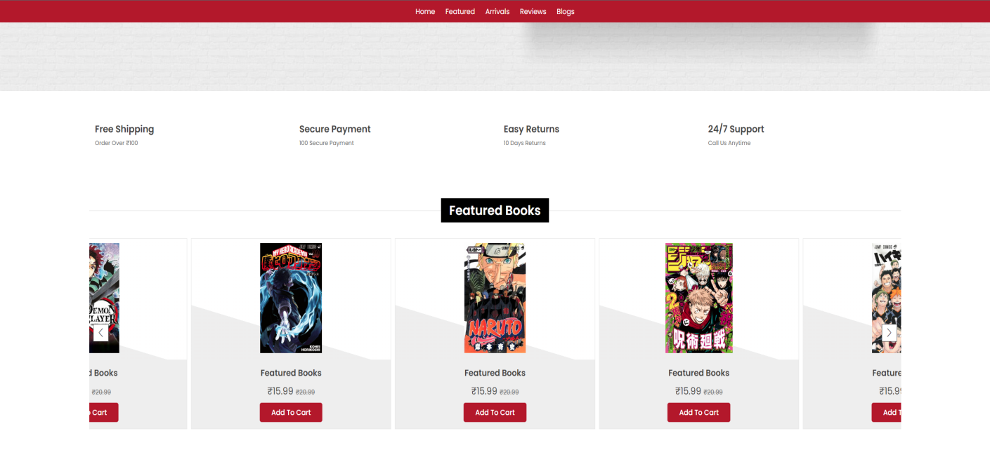

Figure 6.1: Featured Manga & E-book

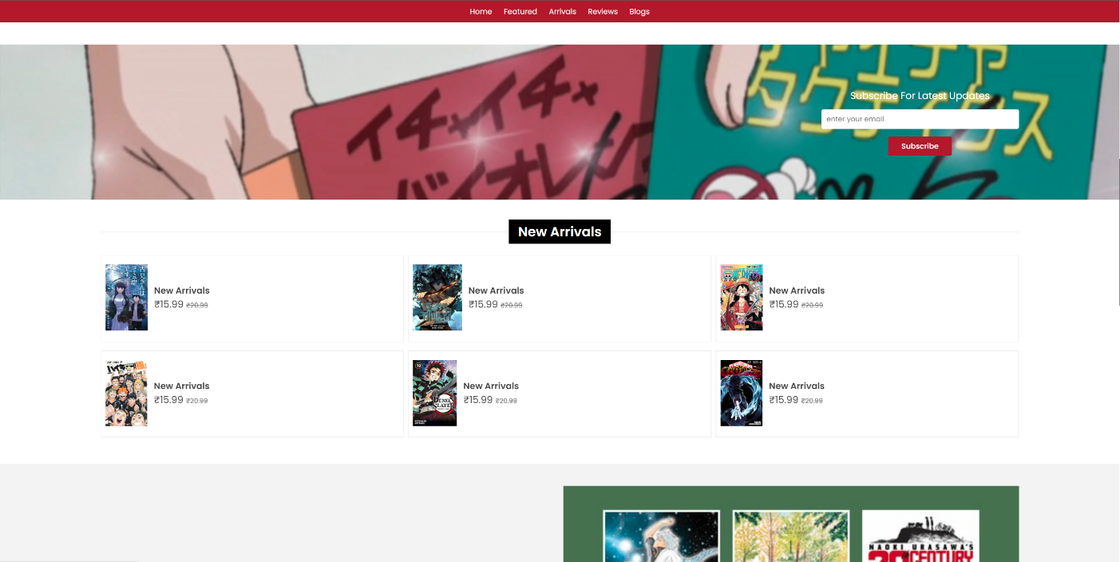

Figure 6.2: New Arrivals

# Chapter 7

**CONCLUSION AND FUTURE**

**ENHANCEMENTS**

## Conclusion

We conclude that by using Html and CSS website for Reading eBooks and Manga you can get the best Reading experience and through Recommendations from the Information gained through User Interaction will provide the best related books and manga to the user to read. Through the Featured and Offers Section, it can be made that the user experience’s the best entertainment and knowledge to grow and implement their knowledge Improve and Make it so that more people will have access for books and learn.

Future Enhancements

This project can be improvised by making this website into a separate application, so that it could get more optimized for users to interact with the data gathered through this work we can use this for improving Suggestions and featured Books to get the most of the user to learn more and gain knowledge.

# Chapter 8

**SOURCE CODE & POSTER**

**PRESENTATION**

## 9.1 Sample Code

1. <!DOCTYPE html>
2. <html lang="en">
3. <head>
4. <meta charset="UTF-8">
5. <meta http-equiv="X-UA-Compatible" content="IE=edge">
6. <meta name="viewport" content="width=device-width, initial-scale=1.0">
7. <title>Nameless Manga-Ten</title>
8. <link rel="stylesheet" href="https://unpkg.com/swiper@7/swiper-bundle.min.css" />
9. <!-- font awesome cdn link -->
10. <link rel="stylesheet" href="https://fonts.googleapis.com/css2?family=Lato:ital@1&display=swap" rel="stylesheet">
11. <!-- custom css file link -->
12. <link rel="stylesheet" href="css/style.css">
13. </head>
14. <body>
15. <!-- header section starts -->
16. <header class="header">
17. <div class="header-1">
18. <a href="#" class="logo"> <i class='fas fa-book' style='font: size 18px;color:red'></i> The Nameless Manga-Ten </a>
19. <form action="" class="search-form">
    1. <input type="search" name="" placeholder="search here..." id="search-box">
    2. <label for="search-box" class="fas fa-search"></label>
20. </form>
21. <div class="icons">
    1. <div id="search-btn" class="fas fa-search"></div>
    2. <a href="#" class="fas fa-heart"></a>
    3. <a href="#" class="fas fa-shopping-cart"></a>
    4. <div id="login-btn" class="fas fa-user"></div>
22. </div>
23. .btn{
24. margin-top: 1rem;
25. display:inline-block;
26. padding:.9rem 3rem;
27. border-radius: .5rem;
28. color:rgb(255, 255, 255);
29. background:var(--red);
30. font-size: 1.7rem;
31. cursor: pointer;
32. font-weight: 500;
33. }
34. .btn:hover{
35. background:var(--dark-color);
36. }
37. .header .header-1{
38. background:#fff;
39. padding:1.5rem 9%;
40. display: flex;
41. align-items: center;
42. justify-content: space-between;
43. }
44. .header .header-1 .logo{
45. font-size: 2.5rem;
46. font-weight: bolder;
47. color:var(--black);
48. }
49. .header .header-1 .logo i{
50. color:var(--red);
51. }
52. .header .header-1 .search-form{
53. width:50rem;
54. height:5rem;
55. border:var(--border);
56. overflow: hidden;
57. background:#fff;
58. display:flex;
59. align-items: center;
60. border-radius: .5rem;
61. }
62. .header .header-1 .search-form input{
63. font-size: 1.6rem;
64. padding:0 1.2rem;
65. height:100%;
66. width:100%;
67. text-transform: none;
68. color:var(--black);
69. }
70. .header .header-1 .search-form label{
71. font-size: 2.5rem;
72. padding-right: 1.5rem;
73. color:var(--black);
74. cursor: pointer;
75. }
76. .header .header-1 .search-form label:hover{
77. color:var(--red);
78. }
79. .header .header-1 .icons div,
80. .header .header-1 .icons a{
81. font-size: 2.5rem;
82. margin-left: 1.5rem;
83. color:var(--black);
84. cursor: pointer;
85. }
86. .header .header-1 .icons div:hover,
87. .header .header-1 .icons a:hover{
88. color:var(--red);
89. }
90. #search-btn{
91. display: none;
92. }
93. .header .header-2{
94. background:var(--red);
95. }
96. .header .header-2 .navbar{
97. text-align: center;
98. }
99. .header .header-2 .navbar a{
100. color:#fff;
101. display: inline-block;
102. padding:1.2rem;
103. font-size: 1.7rem;
104. }
105. .login-form-container form h3{
106. font-size: 2.5rem;
107. text-transform: uppercase;
108. color:var(--black);
109. text-align: center;
110. }
111. </body>
112. </html>

# References

1. Kralj, Lidija. "E-safety and Digital Skills as Part of School Curriculum." Medijske studije (2016)
2. Mehmet Kesim, Hakan Yıldırım “A literature review and content analysis on interactive EBooks” 2017
3. Badulescu, Dana. "Reading in the Digital Age." Philologica Jassyensia 12.1 (2016)
4. Jenny, Bernhard, et al. "E-book atlases for tablet computers: the Atlas of the Columbia River Basin." Journal of Maps 11.4 (2015)
5. Zipke, Marcy. "Building an E!Book Library." The Reading Teacher 67.5 (2014)
6. Shuker, Mary-Jane, and Lisa Terreni. "Self-authored e-books: Expanding young children's literacy experiences and skills." Australasian Journal of Early Childhood 38.3 (2013)
7. Huang, Yueh-Min, et al. "Empowering personalized learning with an interactive e-book learning system for elementary school students." Educational Technology Research and Development 60.4 (2012): 703-722.
8. Felvegi, Emese, and Kathryn I. Matthew. "eBooks and Literacy in K–12 Schools." Computers in the Schools 29.1-2 (2012
9. Velagić, Zoran. "The discourse on printed and electronic books: analogies, oppositions, and perspectives." Information research 19.2 (2014).
10. Sheehan, Kelly J., and David H. Uttal. “Children’s Learning from Touch Screens: A Dual Representation Perspective.” Frontiers in psychology 7 (2016)
11. Morrato, Elaine H., et al. "Bringing it home: expanding the local reach of dissemination and implementation training via a university-based workshop." Implementation Science 10.1 (2015): 94.
12. Schugar, Heather Ruetschlin, Carol A. Smith, and Jordan T. Schugar. "Teaching with interactive picture e!books in grades K–6." The Reading Teacher 66.8 (2013)